Unit 6 测试题
(时间：60分 满分：100分)
I. 单项选择 (15 分)
( ) 1. — Is Peter ________ American boy?
— Yes, he is from New York.
A. a B. an C. the D. /
( ) 2. Listen! Your mother is talking with your aunt ________ the phone.
A. on B. in C. at D. for
( ) 3. At school Lily’s brother doesn’t like ________ subjects. He only likes playing
basketball.
A. some B. many C. much D. any
( ) 4. My grandfather is sixty years old but he looks very ________.
A. small B. young C. tall D. new
( ) 5. Lots of ________ are playing games on the playground.
A. children B. woman C. teacher D. student
( ) 6. — People all like the hamburgers in the food store.
— Yeah! They’re very ________.
A. boring B. easy C. delicious D. funny
( ) 7. — What is Maria doing now?
— She is ________ a book in the library.
A. seeing B. watching C. reading D. looking
( ) 8. There is no fruit at home. Please buy some when you go to the ________.
A. pool B. supermarket C. library D. kitchen
( ) 9. — Where’s Jenny?
— She’s ________ in her room. She has an English test tomorrow.
A. swimming B. studying C. shopping D. dancing
( )10. My sweater is dirty. Can you help me ________ it, Mom?
A. wash B. wear C. read D. buy
( )11. I don’t see my cousin for a long time so I ________ her very much.
A. miss B. like C. think D. know
( )12. — I leave my eraser at home. Can I ________ yours, Helen?
— Yes. Here you are.
A. take B. use C. make D. want
( )13. — Can you ________ with me tomorrow?
— Sure, I love movies.
A. go to the movies B. go to the zoo
C. go to school D. go to work
( )14. — Is your mother watching TV now?
— ________. She is cleaning the room.
A. Yes, she does B. Yes, she is
C. No, she doesn’t D. No, she isn’t
( )15. — ________?
— I’m listening to a CD.
A. Where are you
B. How are you
C. What do you like doing
D. What are you doing
Ⅱ.完形填空（10分）
Today is Elle’s 12-year-old birthday. She is 16 a party at home. Her parents are busy in the 17 . They are making delicious food. Elle’s friends all 18 . Now it’s the birthday cake time. Elle is making a wish. She 19 to be happy every day. 20 are her friends doing? Ben, Jenny and Lisa are 21 the birthday song for Elle. Sam is taking a 22 of them. He wants to keep the happy time in his camera (相机). Where is Elle’s brother Danny? Oh, he is talking on the phone. It’s 23 Elle’s cousin Alice. Alice is studying in the US, 24 she can’t come to Elle’s party. She is calling to say “ 25 ” to Elle.
( )16. A. having B. watching C. playing D. thinking
( )17. A. library B. kitchen C. store D. classroom
( )18. A. leave B. know C. come D. follow
( )19. A. feels B. learns C. wishes D. forgets
( )20. A. Where B. How C. What D. Why
( )21. A. making B. singing C. reading D. listening
( )22. A. photo B. number C. pair D. look
( )23. A. to B. with C. for D. from
( )24. A. because B. but C. so D. or
( )25. A. Good morning B. Happy birthday C. See you D. Thank you
Ⅲ.阅读理解（20分）
A
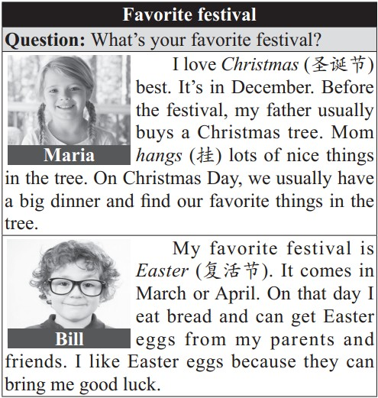
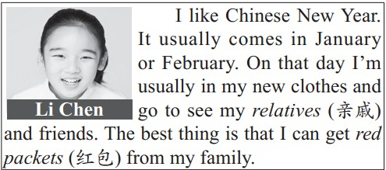
根据材料内容，选择最佳答案。
( )26. What is Maria’s favorite festival?
A. Christmas Day. B. Easter.
C. New Year. D. Children’s Day.
( )27. When is Easter?
A. In January. B. In March or April.
C. In October. D. In December.
( )28. What does Bill eat on Easter?
A. Noodles. B. Cake.
C. Bread. D. Eggs.
( )29. What is the best thing for Li Chen on Chinese New Year?
A. She can wear new clothes.
B. She can see her friends.
C. She can eat nice food.
D. She can get red packets.
( )30. Which of the following is TRUE?
A. Maria usually gets lots of nice things from her friends on Christmas Day.
B. Bill’s favorite festival is Chinese New Year.
C. Li Chen’s parents don’t let her go out on Chinese New Year.
D. Bill thinks Easter eggs can bring him good luck.
B
Dear Dad and Mom,
How are you? I’m happy here, but I miss you very much. It’s Sunday today. I don’t have classes. I am writing an e-mail to you in the computer room now. There are lots of students here. Some students are talking with their friends on QQ. Some students are playing computer games. Some students are watching movies on computers. My new friends, Peter and Bill, are here with me. Peter is buying a T-shirt on the Internet. And what is Bill doing? Oh, he is reading a book on the computer. They’re friendly and they often help me with my study and life. When you come to Shanghai, I want you to meet them. I’m OK in Shanghai. Please don’t worry (担心) about me. I hope you are happy and well.
Love,
Jenny
根据邮件内容，选择正确答案。
( )31. Where is Jenny now?
A. At home.
B. In the supermarket.
C. In the library.
D. In the computer room.
( )32. What’s Peter buying?
A. A sweater. B. A T-shirt.
C. A book. D. A basketball.
( )33. What is Bill doing?
- He is talking with his friends on QQ.
B. He is playing computer games.
C. He is reading a book on the computer.
D. He is watching a movie on the computer.
( )34. What does Jenny think of her two new friends?
A. They are friendly. B. They are funny.
C. They are smart. D. They are strict.
( )35. What can we learn from the e-mail?
A. Jenny doesn’t have fun at school.
B. Jenny can speak Chinese well.
C. Jenny is in China now.
D. Jenny doesn’t like Chinese food.

Ⅳ.词语填空（10分）
A. 根据句意及首字母提示写单词完成句子。 (5 分)
36. There is a big swimming p________ in our school.
37. The bread tastes d________ and I like it.
38. — What’s the name of the m________?
— Kung Fu Panda.
39. The h________ has three rooms and a kitchen.
40. The book is boring. Do you have any o_______ ones?
B. 用所给单词的适当形式完成句子。 (5分)
41. Is your father ________(use) the computer in the room?
42. My brother wishes ________(see) his friend in the United States.
43. Mr. Wang has three ________(child), two sons and one daughter.
44. — Can you see Lucy?
— Yes, she’s ________(shop) there.
45. My father ________(drink) tea in the living room now.
Ⅴ. 完成句子 (10 分)
根据要求完成句子，每空一词。
46. Eric’s parents are watching TV at home. (对划线部分提问)
What ________ Eric’s parents ________ at home?
47. Bill likes his host family very much. (改为同义句)
Bill likes his host family _______ _______.
48. Peter’s grandmother exercises every day. (用now 替换every day 改写句子)
Peter’s grandmother _______ _______ now.
49. — Is Bob doing his homework in the class-room? (作否定回答)
— ________, he ________.
50. My mother is washing the clothes now. (改为一般疑问句)
________ your mother ________ the clothes now?
Ⅵ. 情景交际 (10 分)
从方框中选择恰当的句子完成对话，有两个多余选项。
A: Hello, Jane. (51)________
B: I’m watching a talk show with Rose at home.
A: Rose? (52)________
B: She’s my cousin.
A: (53)________
B: She’s from New York, the USA.
A: Oh, what do you think of the talk show?
B: (54)________
A: Then let’s go to the movies.
B: (55)________ When do we go?
A: At half past five.
B: OK. See you then.
A. Who’s Rose?
B. It’s kind of boring.
C. How old is she?
D. That sounds good.
E. What are you doing?
F. How do we get there?
G. Where’s she from?
Ⅶ. 从方框中选择合适的单词并用其正确形式补全短文。 (10 分)
newspaper, wash, make, draw,
drink, do, play, listen, family, child
It’s Sunday today. Kate and her (56)________ are all at home. Let’s see what they are (57)_______ now. Kate’s grandfather is (58)________ tea in the living room. There, you can also see Kate’s father. He is reading a (59)________. Kate’s mother and sister are in the kitchen. Her mother is (60)_______ chicken soup . Her sister is (61)_______ the dishes. Kate’s brother likes music. He is (62)________ to a CD. Where is Kate? She is (63)________ in her room. She likes art. Look! Who are those two (64)________? Oh, they’re Kate’s cousins. They’re (65)________ with a white cat.
Ⅷ.书面表达（15分）
现在是晚上七点钟，格林夫人的四个孩子都在家里。想知道他们在做什么吗？请看图，然后写一篇60词左右的短文介绍一下他们正在做的事情。
____________________________________________________________________________________________________________________________________________________________________________________________________________________________________________________________________________________________________________________________________________________________________________________________________________________________________________________________________________________________________________________________________
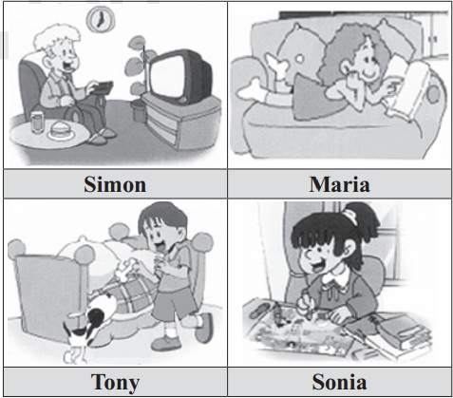

参考答案:
I. 1–5 BADBA 6–10 CCBBA 11–15 ABADD
Ⅱ. 16–20 ABCCC 21–25 BADCB
Ⅲ. 26–30 ABCDD 31–35 DBCAC
Ⅳ.36. pool 37. delicious 38. movie 39. house 40. other 41. using
42.to see 43. children 44. shopping 45. is drinking
Ⅴ. 46. are; doing 47.a lot 48.is exercising 49. No, isn’t 50. Is; washing
Ⅵ. 51–55 EAGBD
Ⅶ. 56.family 57.doing 58.drinking 59. newspaper 60. making
61. washing 62. listening 63. drawing 64. children 65. playing
Ⅷ．One possible version:
Now it’s 7 o’clock in the evening. Mrs. Green’s four children Simon, Maria, Tony and Sonia are all at home. What are they doing? Well, Simon is watching TV in the living room. Maira is also in the living room. She’s reading a book. Tony and Sonia are in their bedrooms. Tony is playing with his dog. Sonia is drawing. They’re all happy.

